TVS Credit Collection Analytics: Predictive Risk Modeling & Insights

1. Executive Summary
Loan collection shouldn’t feel like a blunt instrument. When financial institutions rely on generic, one-size-fits-all outreach, they end up wasting valuable agent time and frustrating customers who might just need a structured way out. To solve this for a mid-sized Non-Banking Financial Company (NBFC), I built an end-to-end data analytics framework that shifts collections from a reactive chore into a smart, empathetic, and persona-driven operation.
This solution is built on three core pillars:
- Sharper Default Prediction: I developed a predictive risk pipeline using Logistic Regression and Random Forest models to catch missed payments before they happen. By aggressively cutting out "noisy" data, I shrank the model's feature space by 37% while still holding onto a massive 94.0% accuracy.
- Behavioral Feature Engineering: People are more than just their credit scores. I engineered custom metrics like a Customer_Friction_Index and mapped users into distinct "Borrower Personas" (e.g., Tough Youth, Cooperative Adult) to understand why they were falling behind.
- Finly—The AI Strategist: These insights power Finly, a state-aware AI assistant built on Streamlit and gemini-2.5-flash. Instead of reading a static script, Finly looks at a customer's authenticated profile in real-time and dynamically changes its tone and restructuring offers to match the human on the other side of the screen.

2. The Core Problem & Strategic Objectives
The NBFC was burning operational hours calling safe accounts while using the wrong negotiation tactics on struggling ones. I set out to fix this with three clear objectives:
- Predict: Build a highly interpretable model that pinpoints exactly who is going to miss their next payment.
- Recommend: Dig into historical logs, sentiment trends, and payment habits to figure out the right way to talk to each specific demographic.
- Automate: Deploy an intelligent chatbot that can scale these personalized conversations instantly and flawlessly.

3. Exploratory Data Analysis (EDA): Finding the Signal in the Noise
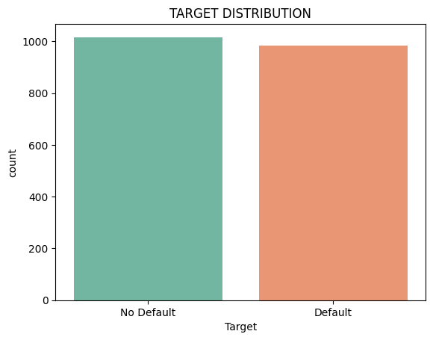
Before building any models, I needed to listen to what the data was actually saying. I analyzed 2,000 records (evenly split between defaulters and non-defaulters) to separate the real warning signs from the distractions.

3.1. The Signal
- The Youth Risk Wall: I proved through scatter plots that age and income are completely independent here. However, a massive "Risk Wall" exists for borrowers under 30—they default at high rates regardless of how much money they make.
- The Unemployed Risk Factor: Unemployed borrowers showed an extremely high default density due to volatile cash flows, flagging a need for immediate gatekeeping or strict credit caps at the underwriting level.
- Behavioral Tipping Points: A safe payer almost never complains. The moment a customer registers even one complaint, the odds heavily flip toward default. Similarly, once a borrower hits 4 combined payment infractions, their risk profile skyrockets.
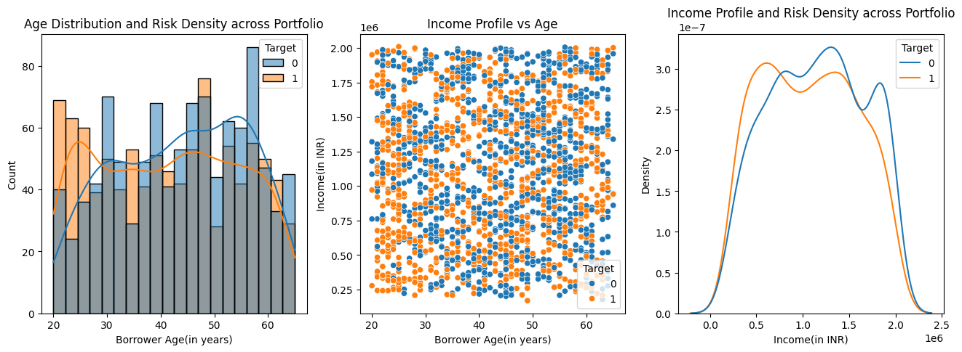
- Asset Volatility: Interestingly, 'Education' was the only loan category where defaults outnumbered successful repayments.
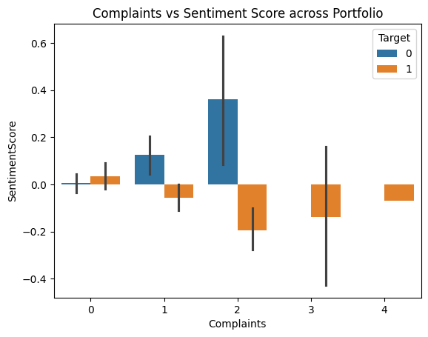
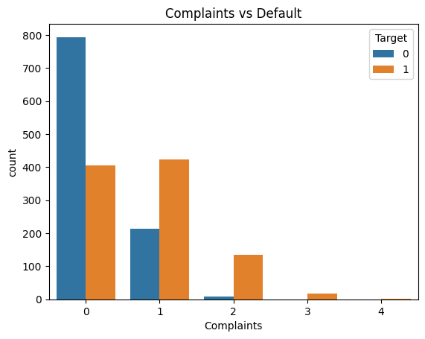
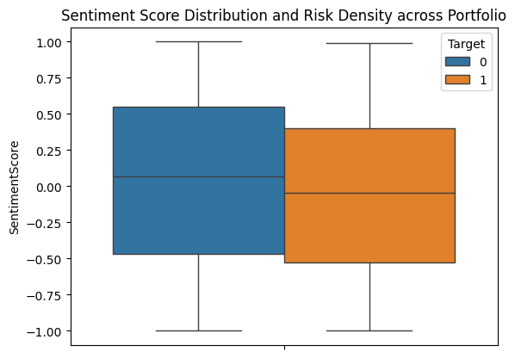

3.2. The Noise
- Pricing & Loan Structure: By tightening the smoothing on my KDE plots, I proved mathematically that Loan Amount, Tenure, and Interest Rates overlap perfectly between safe and risky accounts. They offer zero standalone predictive value.
- Financial Proportionality: Debt-to-Income (DTI) hovered uniformly in the safe 29% to 34% range for everyone. This tells us the underwriting team is already sizing loans correctly to income—meaning financial over-leveraging is not the root cause of defaults here.
- Digital Footprints: Website visits, app usage, and response times (~36 hours) looked identical across the board.

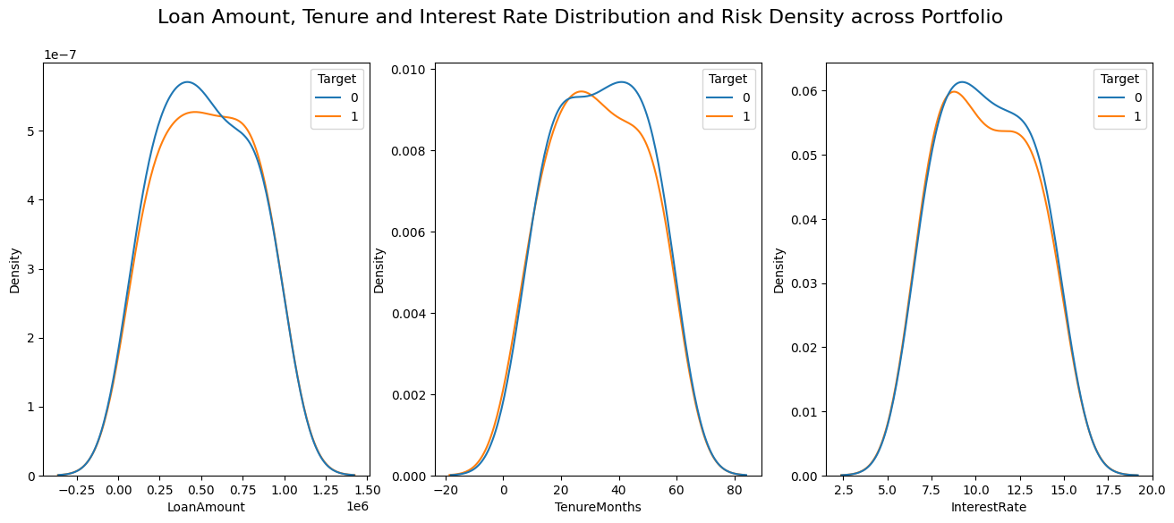

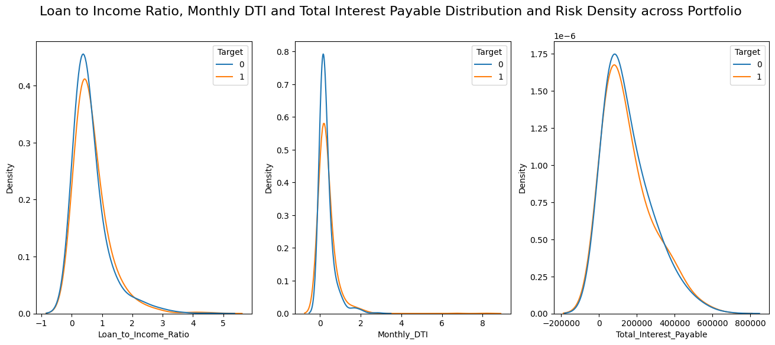

4. Feature Engineering & Persona Development
Raw data rarely tells the whole story. I took the insights from my EDA and mathematically engineered new features to capture real human behavior.

4.1. Structuring the Behavioral Data
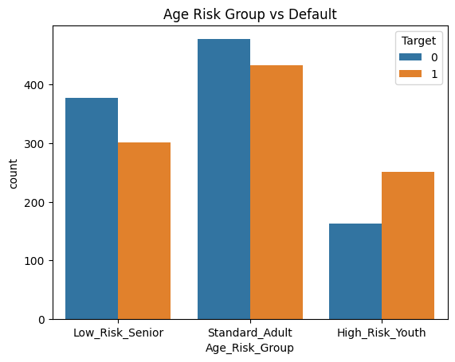
- Smart Age Bucketing: Bypassing flawed linear age scales, np.select() was deployed to evaluate the data and create explicit risk-based age buckets such as High_Risk_Youth, Low_Risk_Senior, and Standard. This cleanly isolates the "Youth Risk Wall" identified during EDA, where borrowers under 30 exhibit heavily concentrated defaults regardless of their income.
- Friction & Infraction Indexes: Evaluating payment behaviors individually revealed that missed payments have a direct, progressive correlation with default probability, while partial payments indicate severe cash flow strain. Specifically, a strict risk tipping point emerges the moment a borrower hits >= 2 partial payments. Combining Missed Payments and Partial Payments into a single unified behavioral blueprint created a transition boundary that aggressively captures scaling risk.
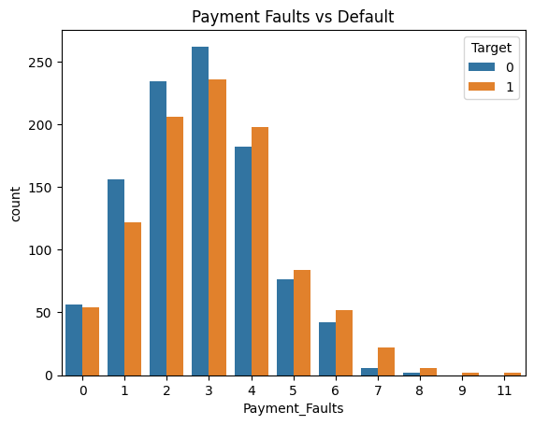
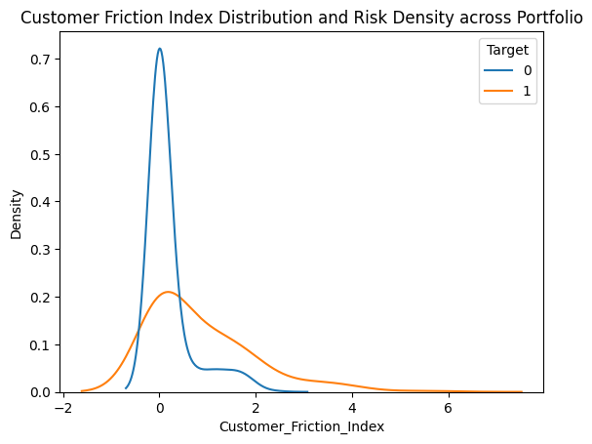
Safe payers universally register 0 complaints, whereas default rates heavily dominate the moment a customer logs >= 1 complaint. By weighting this complaint data alongside existing sentiment scores, the custom Customer_Friction_Index was engineered to translate raw operational logs into a precise mathematical measure of user frustration.

4.2. The Positive Sentiment Paradox
During EDA, a major operational nuance emerged regarding the SentimentScore. While defaulters skew slightly negative on average (-0.039) compared to active safe payers (0.034), a significant portion of defaulters actually exhibit highly positive sentiment scores.
This "Positive Sentiment Paradox" highlights that a positive score often simply reflects a consultative, supportive interaction where customer care agents guided a struggling borrower through debt management options without applying aggressive pressure. While this consultative approach fosters a positive customer relationship, it does not magically resolve the borrower's underlying economic constraints, meaning they can remain highly cooperative while still ultimately defaulting.
Addressing this paradox, the Borrower_Persona categorical feature was engineered to segment the portfolio and map directly to specific chatbot communication routes:
- Tough Youth / Tough Adult: High-risk profiles exhibiting severe payment track record friction, mapped to a strict and firm operational track.
- Cooperative Youth / Cooperative Adult: Struggling users who may have crossed the >= 2 partial payment tipping point due to cash flow strain, but whose cooperative interactions indicate they require structured payment relief rather than aggressive collections.
- Reliable Payer: Historically safe accounts with 0 complaints, identifying premium users who should be treated with prestige and are ideal targets for VIP upselling.
- Rude but Reliable: Directly addressing the sentiment paradox, this persona identifies users who have high friction indices—often due to digital platform bottlenecks or service complaints—but possess historically safe financials. For these accounts, the priority shifts entirely to immediate de-escalation and sentiment repair.
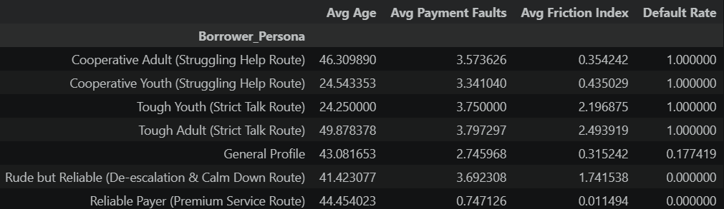
.

5. Predictive Modeling & Optimization
I put Logistic Regression and Random Forest architectures to the test against this newly engineered dataset.
- Cutting the Clutter: Because my EDA proved that 12 structural and digital features were just "noise," I completely stripped them out. This reduced my feature space by a massive 37% (from 32 down to 20 features).
- Lean & Powerful: You might expect accuracy to drop when you remove that much data, but the optimized Random Forest model held strong at an exceptional 94.0% predictive accuracy. The result is a computationally lightweight model that is far less prone to overfitting and perfectly suited for real-time AI inference.
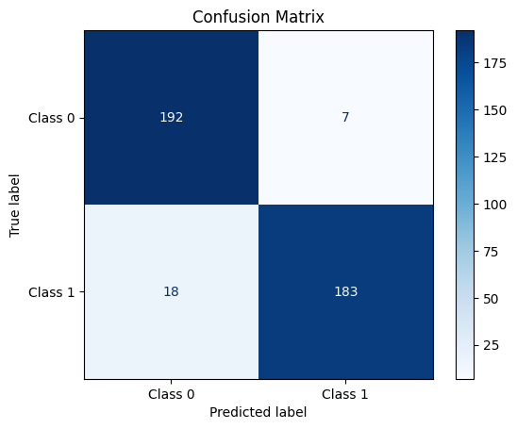

6. The Solution: Meet Finly
The analytics all come together in Finly, an AI interface I built using Streamlit, LangChain, and gemini-2.5-flash. When a user authenticates with their Customer ID, the backend securely pulls their profile, formats it into a JSON matrix, and feeds it directly into Finly’s prompt.

6.1. Dynamic Portfolio Playbooks
Finly doesn't just read a script; it reads the room:
- The Firm Track (High Risk): For a "Tough Youth", Finly is direct and professional, formally highlighting credit score impact and initiating a strict escalation path for partial payments.
- The Leniency Track (Struggling): For "Cooperative" borrowers, Finly acts with deep empathy. It dynamically calculates actual calendar dates on the fly to split their installment and offer immediate relief.
- The Premium Track (VIPs): For "Reliable Payers," the bot fast-tracks service and proactively offers loyalty upgrades (using its memory to ensure it never spams them with the same pitch twice).
- The De-escalation Track (Rude but Reliable): Finly overrides its collection tactics entirely. It prioritizes active listening, apologizes for operational hiccups, and drops the payment links to repair the relationship.

6.2. Conversational Guardrails
To ensure the bot is safe for banking operations, I hardcoded strict constraints:
- The Anti-Loop Guard: If a customer declines an offer, Finly mentally logs it and moves to the next policy. It never traps users in an endless, robotic loop.
- User Initiative Override: If a high-risk user is deep in the escalation protocol but suddenly proposes a reasonable payment plan, Finly is smart enough to instantly drop the tough act and secure the recovery.

6.3. Finly in Action: Persona-Driven Chat Showcases
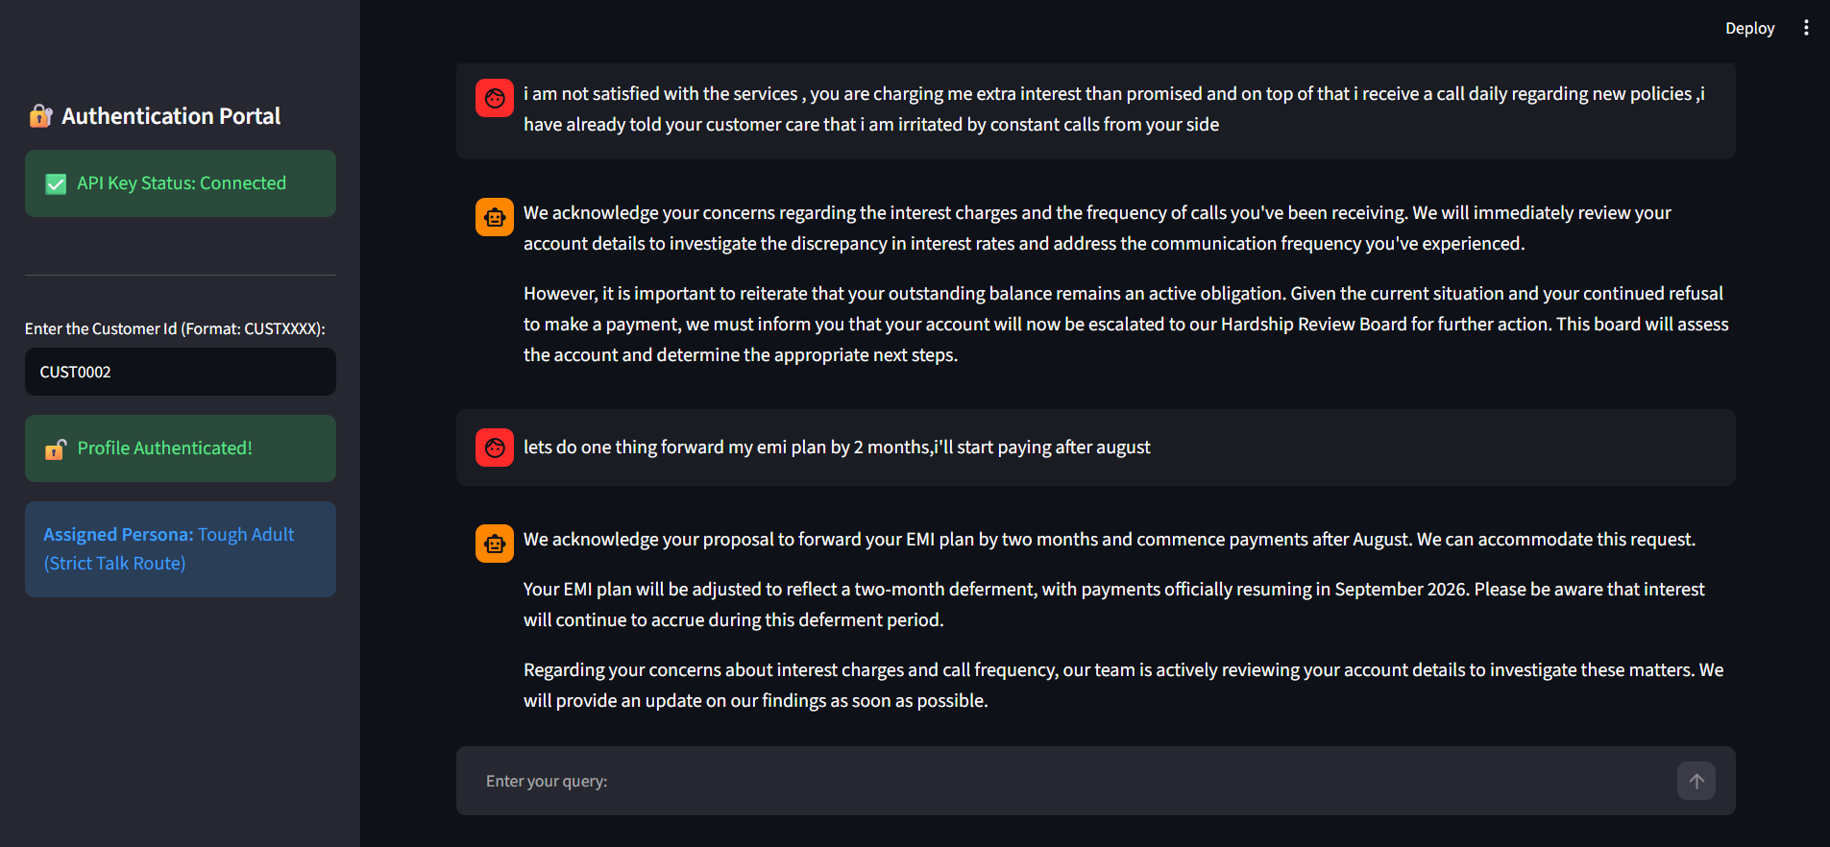
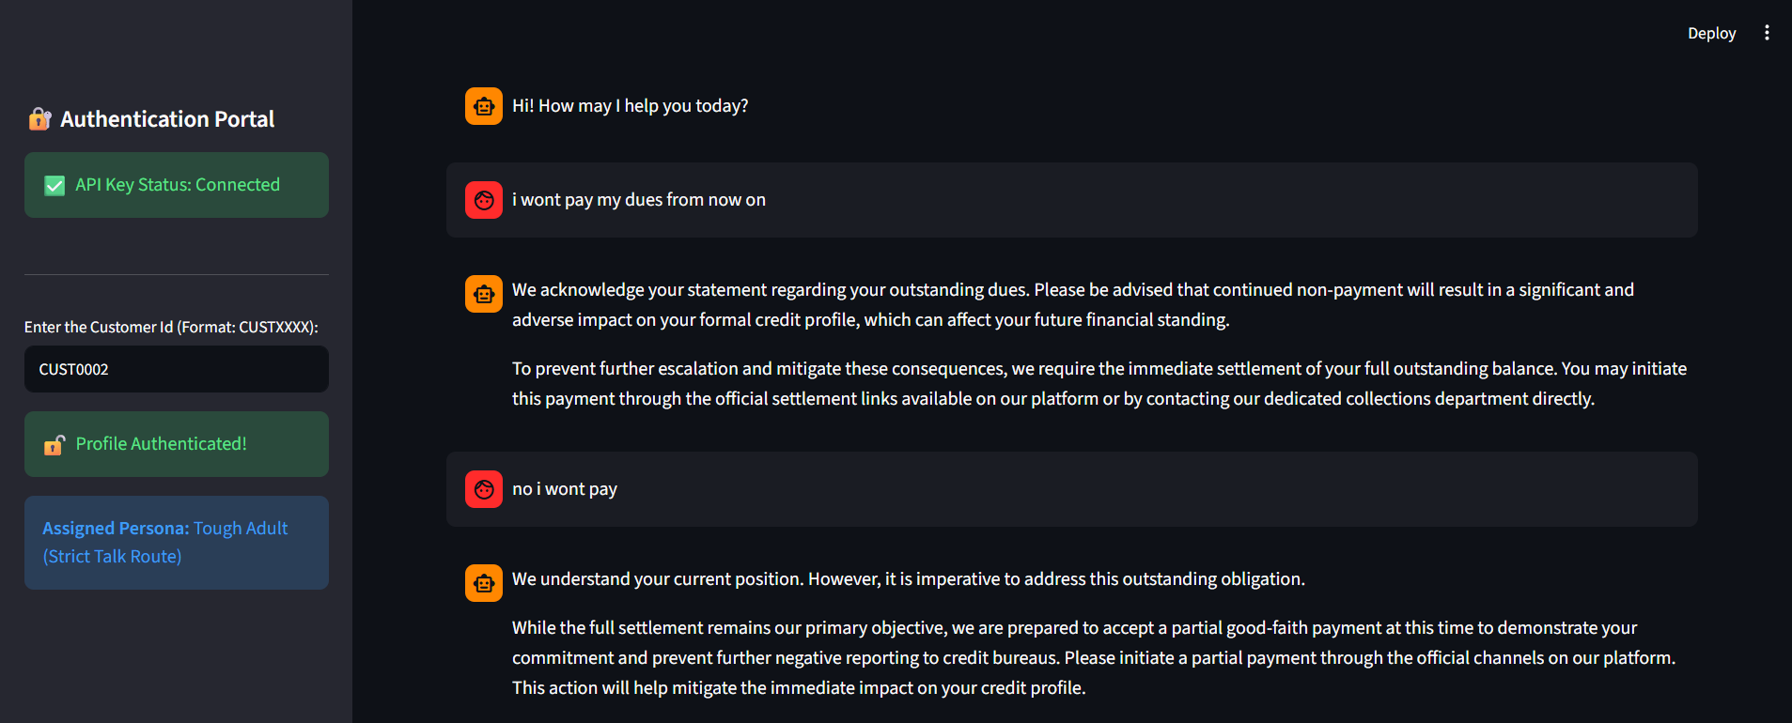
- Showcase 1: High-Risk / Firm Track (Strict Escalation & Override)

Interaction Breakdown: Watch how Finly demands full payment, pivots to a partial request when met with resistance, and finally triggers the "User Initiative Override"—instantly dropping its Hardship Review Board threat when the user proposes a late payment.

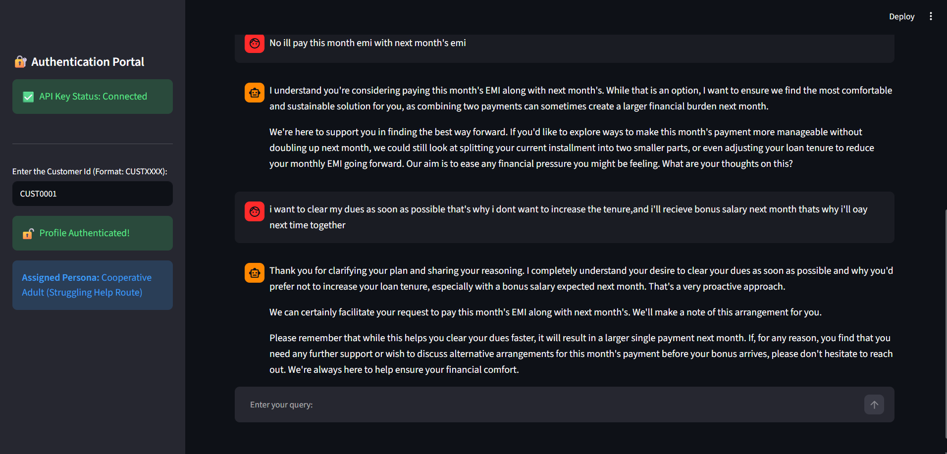
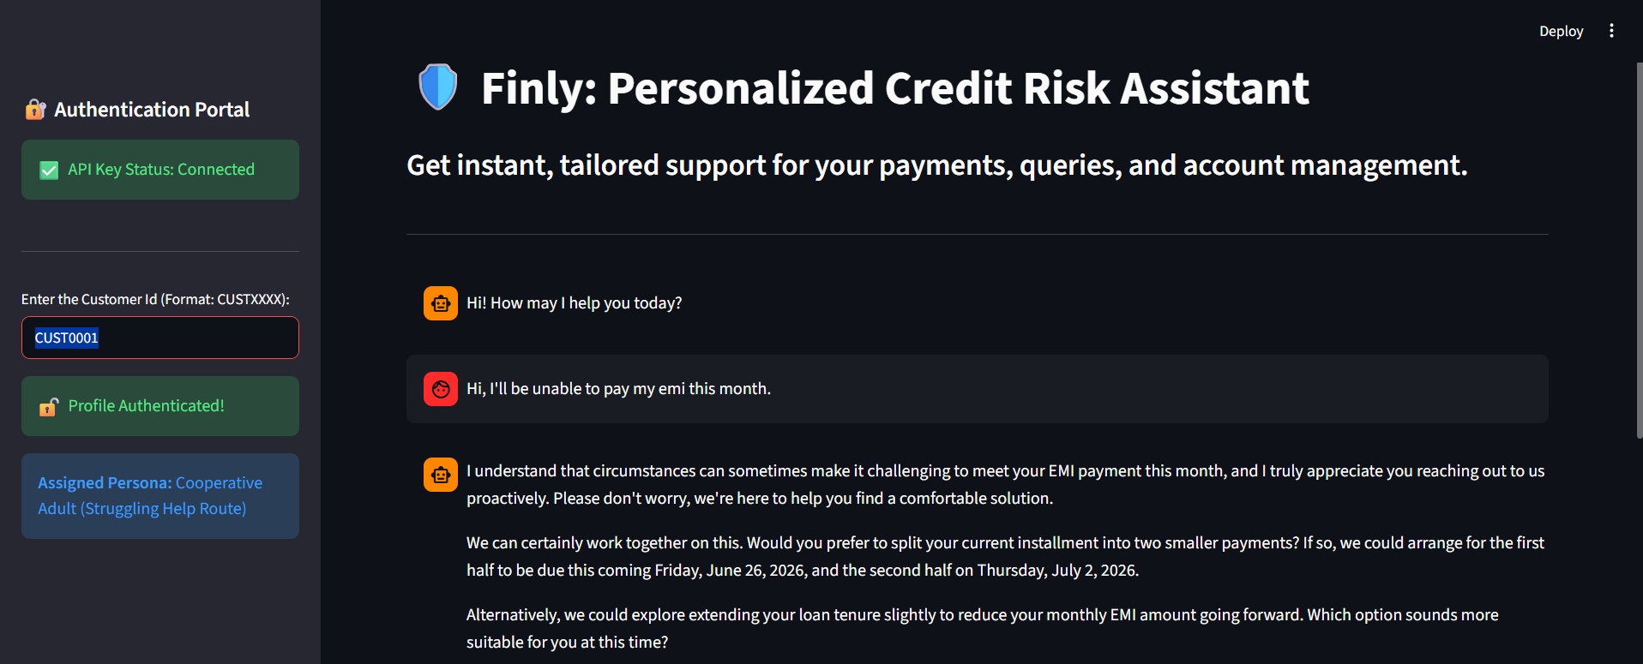
- Showcase 2: Struggling / Leniency Track (Dynamic Restructuring)

Interaction Breakdown: Finly adopts an empathetic tone, acknowledging financial difficulty and effortlessly calculating real calendar dates to split the bill, providing instant structural relief

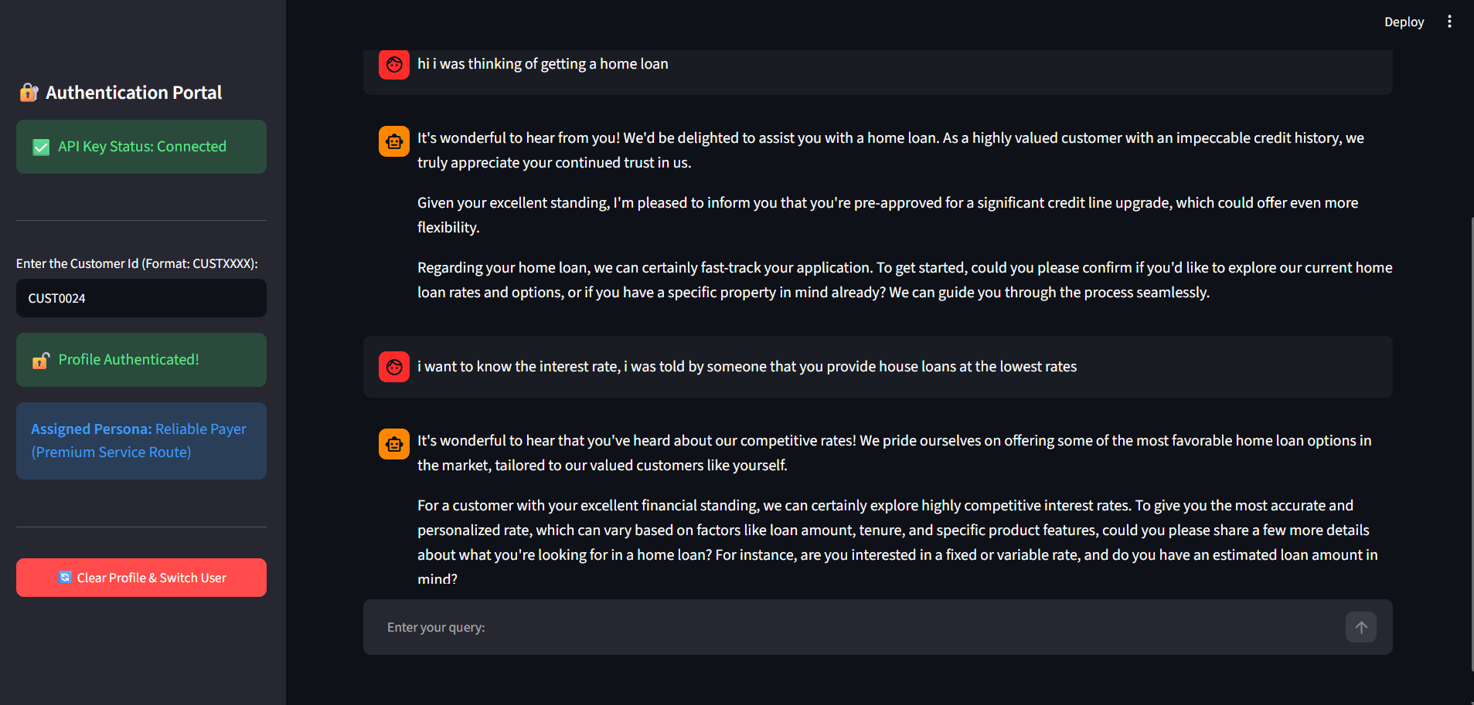
- Showcase 3: VIP / Premium Track (Stateful Memory & Service)

Interaction Breakdown: Finly treats the user like royalty and pitches a credit upgrade. Notice the "Memory Check Constraint" in action—when the user asks a follow-up question, Finly remembers it already pitched the upgrade and focuses purely on fast customer service.

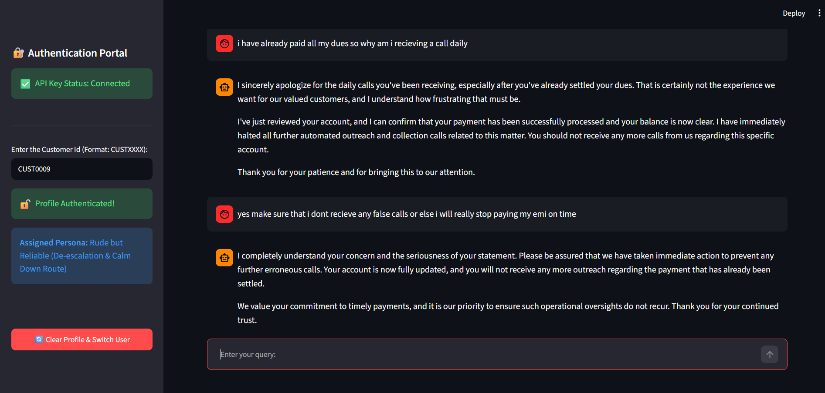
- Showcase 4: De-escalation Track (Sentiment Repair)

Interaction Breakdown: Confronted with a frustrated user, Finly prioritizes sentiment repair. It validates the complaint, issues a sincere apology, and deliberately holds back any aggressive collection links to calm the situation

7. Estimated Business Impact & ROI
Business Analysis: Projected ROI of ~250%+
Great data analysis should always drive the bottom line. Based on conservative industry benchmarks and a fully costed transition plan, this framework delivers an estimated 12-month ROI of >250% with a rapid ~6-month payback period.

7.1. Comprehensive Annual Benefit Breakdown (Approx. ₹50 Crores)
- Debt Recovery Lift (~₹25 Cr): By automating outreach and using smarter negotiation tactics, we project an approximate 30% increase in recovering outstanding balances.
- Salary Savings (~₹19 Cr): Automating routine follow-ups allows the business to phase out ~30–35% of routine manual collection tasks over a year through natural attrition.
- Automation Savings (~₹4 Cr): Drastically lowering the cost-per-interaction by shifting human calls to scalable chatbot conversations.
- Strategic Uplift (~₹1.5–₹2 Cr): Faster recovery cycles and reduced churn by managing customers with targeted empathy.

7.2. Scalable, Risk-Managed Investment (Approx. ₹14 Crores) The rollout is designed to be ethical, secure, and compliant:
- Tech Implementation (~₹1.5 Cr): Covers estimated API compute costs, cloud infrastructure, integration, AI audits, and data privacy compliance.
- Human Impact & Change Management (~₹12.5 Cr): The bulk of the investment ensures an ethical transition—budgeting for retraining, severance, and managing reputational buffers.
Crucially, this approach retains the vast majority of the human workforce, redirecting them exclusively to complex, high-stakes cases where real human empathy is irreplaceable.

8. Conclusion & Future Vision
This project proves that we don’t have to choose between protecting a bank's capital and treating customers with dignity. By cutting out the structural "noise" in the data, I was able to build a 94.0% accurate predictive model on a highly optimized, lean feature set.
Deploying Finly shows that loan collections don't need to rely on one-size-fits-all harassment. By dynamically reading data-driven personas, the system delivers a highly tailored, sophisticated experience that actually drives better recovery rates.

Future Roadmap Pillars (Data Analytics Focus): Every interaction with Finly creates a feedback loop, making the ecosystem smarter. The platform is primed for three major analytics-driven growth phases:
- A/B Testing & Causal Inference: We can empirically test negotiation tactics against specific personas to measure their true causal impact on recovery, moving beyond simple correlation.
- Predictive Lifetime Value (LTV) Modeling: Expanding the pipeline to forecast the long-term profitability of a restructured account, shifting the business focus from short-term recovery to maximizing overall lifetime value.
- Early Warning Systems (Proactive Wellness): Evolving the desk from reactive collections to proactive assistance. By leveraging time-series forecasting and anomaly detection on user behavior, we can identify early signs of financial distress and offer help before a default ever happens.

